# Statistical Interpretation for Presentation

Violent Crime Rate

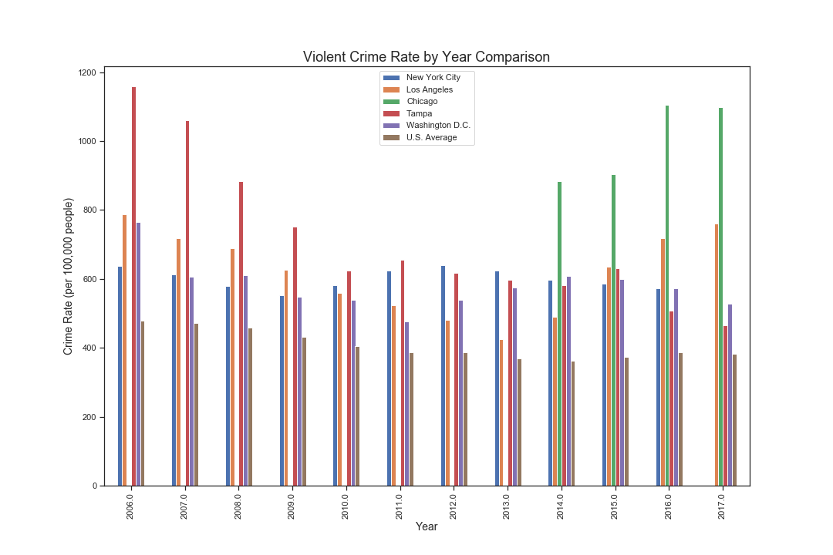

Regressions

Los Angeles: R = -0.186, p = 0.563

New York City: NaN

Chicago: NaN

Tampa: R = -0.897, p = 0.0000757

Washington D.C.: R = -0.449, p = 0.143

U.S. Average: R = -0.871, p = 0.000222

ANOVA

F = 11.3855

P = 0.0000118

Graduation Rate

Regressions

Los Angeles: R = 0.994, p = 0.00000500

New York City: R = 0.992, p = 0.0000119

Chicago: R = 0.993, p = 0.00000848

Tampa: R = 0.975, p = 0.00019

Washington D.C.: R = 0.994, p = 0.0000059

U.S. Average: R = 1.0, p = 1.9206 x 10-50

ANOVA

F = 96.20

p = 8.48 x 10-20

Poverty Rate

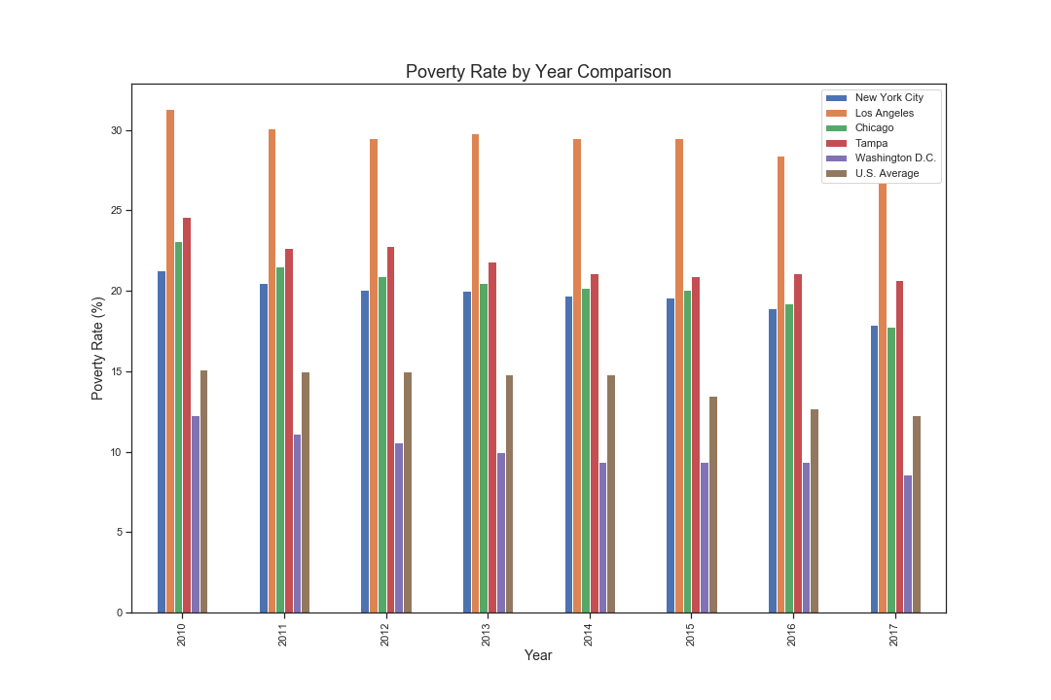

Regressions

Los Angeles: R = -0.893, p = 0.00286

New York City: R = -0.958, p = 0.000178

Chicago: R = -0.957, p = 0.000187

Tampa: R = -0.912, p = 0.00158

Washington D.C.: R = -0.95, p = 0.000295

U.S. Average = -0.908, p = 0.00177

ANOVA

F = 216.92

p = 7.49 x 10-29

Median Income

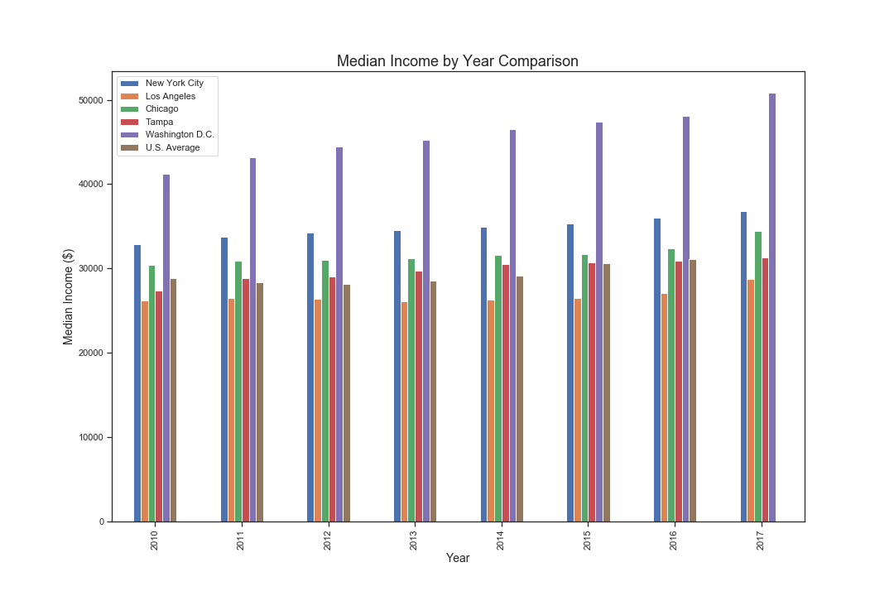

Regressions

Los Angeles: R = 0.989, p = 0.166

New York City: R = 0.989, p = 2.47 x 10-5

Chicago: R = 0.971, p = 0.000272

Tampa: R = 0.963, p = 0.000482

Washington D.C.: R = 0.988, p = 3.1 x 10-5

U.S. Average: R = 0.828, p = 0.0215

ANOVA

F = 176.65

p = 2.82 x 10-24

Graduation Rate vs. Median Income

Regression for All Points

R = 0.705

P = 1.82 x 10-7

ANCOVA

Comments:

Violent Crime Rate

* The p values are terrible
* ANOVA was run without New York City or Chicago
* Linear regression is not good at predicting Violent Crime rate over the years

Graduation Rate

* Excellent regressions, all linear
* Means the model is R=% accurate at predicting the rates for following years
* ANOVA has a high F

Poverty Rate

* Decent regressions, all linear
* ANOVA has a high F

Median Income

* Los Angeles isn’t statistically significant
* All downward trending (good thing)
* ANOVA has a high F

Graduation vs. Median Income

* Model is 70% accurate in determining graduation rate based on the median income and vice versa
* Very low p value

ANCOVA

* The City has the strongest relationship to Crime Rate, not the median income, graduation rate, or poverty rate
* While Graduation Rate has a low F value, it’s not statistically significant